# Submitted By: M. Talha Atif

# ID: F2021266573

# Section: Y3

# Submitted To: Sir Ali Harris

## Image 2

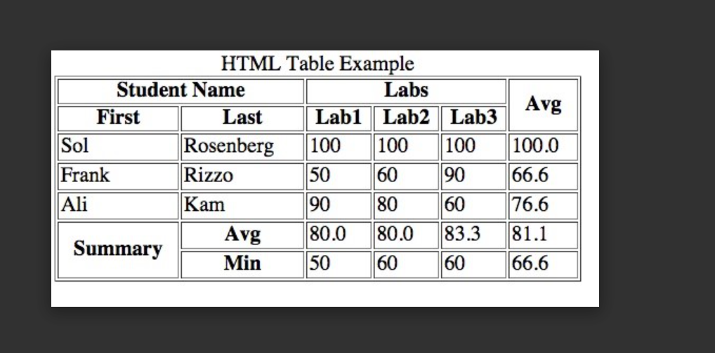

## Code:

<!DOCTYPE html>

<html lang="en">

<head>

    <meta charset="UTF-8">

    <meta name="viewport" content="width=device-width, initial-scale=1.0">

    <title>Table 2</title>

</head>

<body>

    <p  style="background-color: white; font-family: Arial, Helvetica, sans-serif; font-size: 18px; position: relative; left: 90px; ">HML Table Example</p>

    <table border="1">

    <tr>

        <th colspan="2"  style="background-color: blue; color:white; font-family: Arial, Helvetica, sans-serif; font-size: 18px; ">Student Name</th>

        <th colspan="3"  style="background-color: blue; color:white; font-family: Arial, Helvetica, sans-serif; font-size: 18px; ">Labs</th>

        <th rowspan="2" style="background-color: green; color:yellow; font-weight:bold; font-family: Arial, Helvetica, sans-serif; font-size: 14px; ">Avg</th>

    </tr>

    <tr>

        <th style="background-color: white; font-family: Arial, Helvetica, sans-serif; font-size: 18px; ">First</th>

        <th style="background-color: white; font-family: Arial, Helvetica, sans-serif; font-size: 18px; ">Last</th>

        <th style="background-color: red; color:white; font-weight:bold; font-family: Arial, Helvetica, sans-serif; font-size: 10px; ">Lab1</th>

        <th style="background-color: red; color:white; font-weight:bold; font-family: Arial, Helvetica, sans-serif; font-size: 10px; ">Lab2</th>

        <th style="background-color: red; color:white; font-weight:bold; font-family: Arial, Helvetica, sans-serif; font-size: 10px; ">Lab3</th>

    </tr>

    <tr>

        <td style="background-color: white; font-family: Arial, Helvetica, sans-serif; font-size: 14px; ">Sol</td>

        <td style="background-color: white; font-family: Arial, Helvetica, sans-serif; font-size: 14px; ">Rosenberg</td>

        <td style="background-color: white; font-family: Arial, Helvetica, sans-serif; font-size: 14px; ">100</td>

        <td style="background-color: white; font-family: Arial, Helvetica, sans-serif; font-size: 14px; ">100</td>

        <td style="background-color: white; font-family: Arial, Helvetica, sans-serif; font-size: 14px; ">100</td>

        <td style="background-color: white; font-family: Arial, Helvetica, sans-serif; font-size: 14px; ">100.0</td>

    </tr>

    <tr>

        <td style="background-color: white; font-family: Arial, Helvetica, sans-serif; font-size: 14px; ">Frank</td>

        <td style="background-color: white; font-family: Arial, Helvetica, sans-serif; font-size: 14px; ">Rizzo</td>

        <td style="background-color: white; font-family: Arial, Helvetica, sans-serif; font-size: 14px; ">50</td>

        <td style="background-color: white; font-family: Arial, Helvetica, sans-serif; font-size: 14px; ">60</td>

        <td style="background-color: white; font-family: Arial, Helvetica, sans-serif; font-size: 14px; ">90</td>

        <td style="background-color: white; font-family: Arial, Helvetica, sans-serif; font-size: 14px; ">66.6</td>

    </tr>

    <tr>

        <td style="background-color: white; font-family: Arial, Helvetica, sans-serif; font-size: 14px; ">Ali</td>

        <td style="background-color: white; font-family: Arial, Helvetica, sans-serif; font-size: 14px; ">Kam</td>

        <td style="background-color: white; font-family: Arial, Helvetica, sans-serif; font-size: 14px; ">90</td>

        <td style="background-color: white; font-family: Arial, Helvetica, sans-serif; font-size: 14px; ">80</td>

        <td style="background-color: white; font-family: Arial, Helvetica, sans-serif; font-size: 14px; ">60</td>

        <td style="background-color: white; font-family: Arial, Helvetica, sans-serif; font-size: 14px; ">76.6</td>

    </tr>

    <tr>

        <th rowspan="2" style="background-color: green; color: white; font-family: Arial, Helvetica, sans-serif; font-size: 18px; ">Summary</td>

        <th  style="background-color: white; font-family: Arial, Helvetica, sans-serif; font-size: 18px; ">Avg</td>

        <td  style="background-color: white; font-family: Arial, Helvetica, sans-serif; font-size: 14px; ">80.0</td>

        <td  style="background-color: white; font-family: Arial, Helvetica, sans-serif; font-size: 14px; ">80.0</td>

        <td  style="background-color: white; font-family: Arial, Helvetica, sans-serif; font-size: 14px; ">83.3</td>

        <td  style="background-color: white; font-family: Arial, Helvetica, sans-serif; font-size: 14px; ">81.1</td>

    </tr>

    <tr>

        <th style="background-color: white; font-family: Arial, Helvetica, sans-serif; font-size: 18px; ">Min</td>

        <td style="background-color: white; font-family: Arial, Helvetica, sans-serif; font-size: 14px; ">50</td>

        <td style="background-color: white; font-family: Arial, Helvetica, sans-serif; font-size: 14px; ">60</td>

        <td style="background-color: white; font-family: Arial, Helvetica, sans-serif; font-size: 14px; ">60</td>

        <td style="background-color: white; font-family: Arial, Helvetica, sans-serif; font-size: 14px; ">66.6</td>

    </tr>

    </table>

</body>

</html>

## Output:

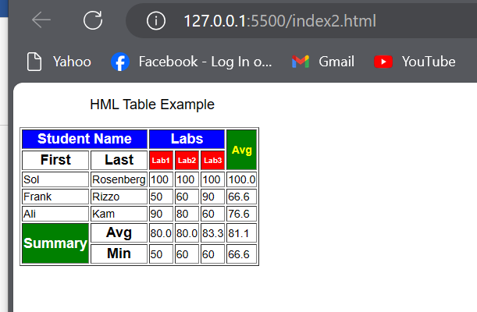

## Image 2:

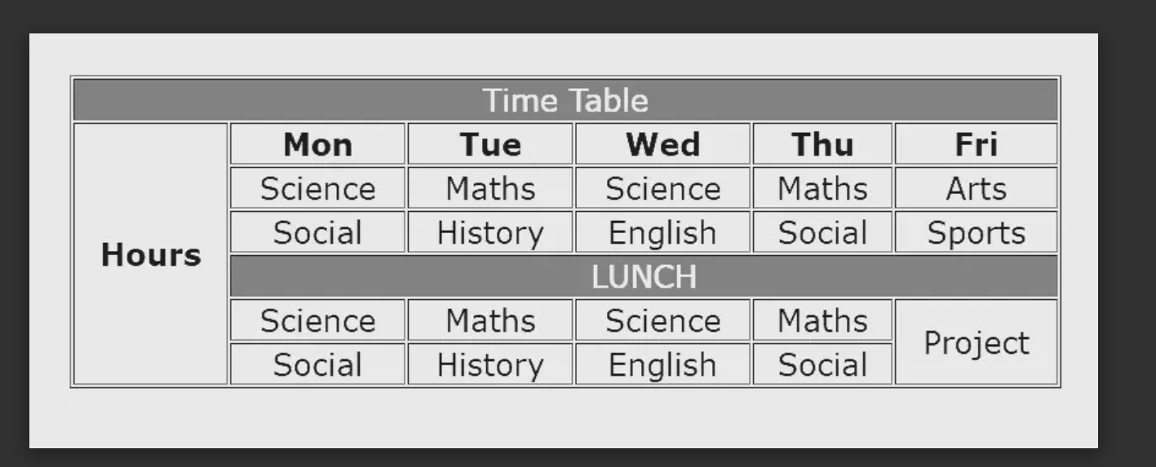

## Code:

<!DOCTYPE html>

<html lang="en">

<head>

    <meta charset="UTF-8">

    <meta name="viewport" content="width=device-width, initial-scale=1.0">

    <title>Table 1</title>

</head>

<body>

    <table border="1">

    <tr>

        <th colspan="6"  style="background-color: blue; color:white; font-family: Arial, Helvetica, sans-serif; font-size: 18px; ">

            Time Table

        </th>

    </tr>

    <tr>

        <th rowspan="6" style="background-color: white; font-family: Arial, Helvetica, sans-serif; font-size: 18px; ">

            Hours

        </th>

        <th style="background-color: white; font-family: Arial, Helvetica, sans-serif; font-size: 18px; ">Mon</th>

        <th style="background-color: white; font-family: Arial, Helvetica, sans-serif; font-size: 18px; ">Tue</th>

        <th style="background-color: white; font-family: Arial, Helvetica, sans-serif; font-size: 18px; ">Wed</th>

        <th style="background-color: white; font-family: Arial, Helvetica, sans-serif; font-size: 18px; ">Thur</th>

        <th style="background-color: white; font-family: Arial, Helvetica, sans-serif; font-size: 18px; ">Fri</th>

    </tr>

    <tr>

        <td style="background-color: white; font-family: Arial, Helvetica, sans-serif; font-size: 14px; ">Science</td>

        <td style="background-color: red; color: white; font-family: Arial, Helvetica, sans-serif; font-size: 14px; ">Maths</td>

        <td style="background-color: white; font-family: Arial, Helvetica, sans-serif; font-size: 14px; ">Science</td>

        <td style="background-color: red; color: white; font-family: Arial, Helvetica, sans-serif; font-size: 14px; ">Maths</td>

        <td style="background-color: white; font-family: Arial, Helvetica, sans-serif; font-size: 14px; ">Arts</td>

    </tr>

    <tr>

        <td  style="background-color: white; font-family: Arial, Helvetica, sans-serif; font-size: 14px; ">Social</td>

        <td  style="background-color: white; font-family: Arial, Helvetica, sans-serif; font-size: 14px; ">History</td>

        <td style="background-color: white; font-family: Arial, Helvetica, sans-serif; font-size: 14px; ">English</td>

        <td style="background-color: white; font-family: Arial, Helvetica, sans-serif; font-size: 14px; ">Social</td>

        <td style="background-color: white; font-family: Arial, Helvetica, sans-serif; font-size: 14px; ">Sports</td>

    </tr>

    <tr>

        <th colspan="5"  style="background-color: blue; color:white; font-family: Arial, Helvetica, sans-serif; font-size: 18px; ">

            Lunch

        </th>

    </tr>

    <tr>

        <td  style="background-color: white; font-family: Arial, Helvetica, sans-serif; font-size: 14px; ">Science</td>

        <td style="background-color: red; color: white; font-family: Arial, Helvetica, sans-serif; font-size: 14px; ">Maths</td>

        <td  style="background-color: white; font-family: Arial, Helvetica, sans-serif; font-size: 14px; ">Science</td>

        <td style="background-color: red; color: white; font-family: Arial, Helvetica, sans-serif; font-size: 14px; ">Maths</td>

        <td colspan="2"  style="background-color: green; color:yellow; font-weight:bold; font-family: Arial, Helvetica, sans-serif; font-size: 20px; ">Project</td>

    </tr>

    <tr>

        <td style="background-color: white; font-family: Arial, Helvetica, sans-serif; font-size: 14px; ">Social</td>

        <td style="background-color: white; font-family: Arial, Helvetica, sans-serif; font-size: 14px; ">History</td>

        <td style="background-color: white; font-family: Arial, Helvetica, sans-serif; font-size: 14px; ">English</td>

        <td style="background-color: white; font-family: Arial, Helvetica, sans-serif; font-size: 14px; ">Social</td>

    </tr>

    </table>

</body>

</html>

## Output:

